Final Internship Report

Submitted in partial fulfilment of the internship requirement
Of
Bachelor of Science Artificial Intelligence

Student Name | Humna Imran
Registration No. | 2023-BS-AI-017
Program | BS Artificial Intelligence
Host Organization | Code Saviours
Internship Duration | 29 June 2026 – 29 August 2026
Industry Supervisor | Ms. Rameesha
University Supervisor | Mr. Arham
Submission Date | 31 August 2026

Department of Computer Science
The University of Faisalabad

- Introduction
Code Saviours is the organisation that hosted my internship under its Artificial Intelligence and Machine Learning internship programme (Batch SI-26). The internship was organised as a structured, project-based curriculum rather than a single fixed assignment: interns were given weekly milestones, were expected to maintain their work in version-controlled GitHub repositories, and were guided toward taking a project from an initial idea through to a working, deployed application. This structure meant that the internship was closely aligned with how AI and Machine Learning work is actually carried out in practice, involving not just model building but also data collection, documentation, debugging, and deployment.
During the internship, I worked on two independent projects, both supervised under the same programme. The first involved building a system to automatically identify Roman Urdu and English words within code-switched text, a Natural Language Processing problem. The second, larger project involved building a custom Optical Character Recognition system for Urdu text, an area that combines computer vision with language processing. Both projects are directly relevant to my BS Artificial Intelligence degree, since they required me to apply supervised learning, transformer-based deep learning architectures, honest evaluation methodology, and practical software engineering skills such as version control and deployment. The remainder of this report describes the work carried out on both projects, what I learned from them, and how the experience contributed to my growth as an early-career AI practitioner.
- Tasks and Responsibilities
Across both projects, my responsibilities spanned the full lifecycle of an applied Machine Learning project: understanding the problem, sourcing and preparing data, building and training models, evaluating results honestly (including when they were disappointing), debugging failures, and packaging the finished work into an application that another person could actually use. Each week of the internship came with a specific assigned deliverable, and the two subsections below describe, project by project, what I was actually asked to do and how I carried it out. Table 1 summarises the main technologies and tools I used to do this.
Table 1: Technologies and Tools Used During the Internship
Category | Tools / Technologies Used
Programming language | Python
Deep learning framework | PyTorch, Hugging Face Transformers
Core models | XLM-RoBERTa (token classification), TrOCR / microsoft-trocr-base-printed
Data handling | pandas, NumPy
Computer vision / preprocessing | OpenCV, Pillow
Baseline OCR engine | Tesseract OCR with the Urdu language pack
Visualization | Matplotlib, Seaborn, scikit-learn
Development environment | GitHub Codespaces; Google Colab (GPU training)
Version control | Git and GitHub
Model and dataset hosting | Hugging Face Hub
Deployment | Streamlit / Streamlit Community Cloud

Both projects were maintained under Git and GitHub throughout, rather than written up after the fact, and the commit history is itself a record of the actual work. The Urdu OCR repository contains 221 commits made between 30 June and 20 August 2026, spanning all five of its weekly stages, and the code-switching repository contains 30 commits made between 7 and 21 August 2026, its two weekly stages. A meaningful share of these commits are plain bug-fix commits (for example, correcting notebook execution counts, handling a FileNotFoundError during dataset loading, and repairing a broken package-installation command), which is consistent with the iterative, trial-and-error process described throughout the rest of this section rather than a single polished attempt.
Project 1: Roman Urdu-English Code-Switching Language Identification
The first project, undertaken in Weeks 6 and 7 of the internship, addressed code-switching: the way many Pakistani social media users mix Roman Urdu and English within the same sentence, and sometimes within the same phrase. Standard NLP tools generally assume a single language per document, so this kind of mixed text is difficult for them to process correctly. My task was to build a model that reads a sentence and classifies each individual word as Urdu (URD), English (ENG), or a mixed or hybrid token (MIX), which makes this a word-level token classification problem rather than a sentence-level one.
Beyond the labelling task itself, this kind of model has fairly direct real-world uses: sentiment analysis on mixed-language text, chatbots and keyboard suggestions that do not break on Roman Urdu, and content moderation systems that currently tend to assume a single language.
Dataset. I built the training data from a public Roman Urdu dataset (the Smat26/Roman-Urdu-Dataset collection of organic Twitter, Facebook, and e-commerce review text, released under a GPL-3.0 licence) rather than starting from scratch. After cleaning and de-duplicating the raw text down to roughly 15,900 usable sentences, I auto-labelled every word using an English wordlist cross-checked against a curated list of common Urdu words that would otherwise be misclassified, then applied a filter to keep only sentences that showed genuine code-switching (a mix of enough Urdu and English words, with English making up a minority of the sentence). This left 220 sentences, which I spot-checked manually before finalising a dataset of 2,490 word-level labels. Figure 1 shows the resulting label balance.
Building the labelling rule itself took a few iterations. A plain English wordlist is not enough to separate the two languages, because a number of short, common Urdu words are also valid English words or are easy to confuse with them: is, mil, beta, and par all caused early mislabelling, for example. I built a curated override list of more than 150 common Urdu words to catch these before the English wordlist could claim them. The genuine code-switching filter also needed tuning: my first pass returned around 300 candidate sentences against a target of 220, and de-duplicating them turned up a subtler bug, where the same sentence had been kept twice because one copy used different capitalisation from the other; comparing sentences case-insensitively before de-duplicating fixed it. When I spot-checked a random sample of the final labels by hand, the automatic labelling held up well, roughly 95% correct by my own estimate, but the remaining errors were genuinely ambiguous rather than careless: the word "mobile", for instance, sits in the English wordlist, but in Pakistani Roman Urdu it gets used constantly as an ordinary Urdu-feeling word ("mera mobile"), which is exactly the kind of judgement call a purely automatic pipeline cannot make on its own.
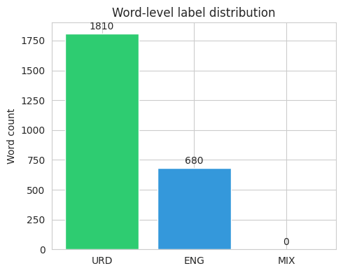
Figure 1: Word-Level Label Distribution in the Code-Switching Dataset
Looking at which words were most frequent within each label also helped me sanity-check the labelling. Figure 2 shows that the most common Urdu-tagged words were everyday grammatical words (hai, ke, ko, mein), while the most common English-tagged words included proper nouns and loanwords, which is consistent with what I would expect from genuinely mixed, informal text.
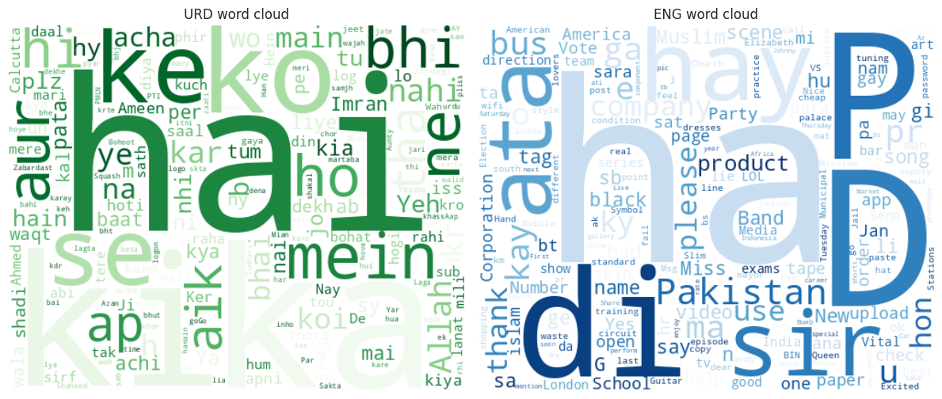
Figure 2: Word Clouds of the Most Frequent Urdu (URD) and English (ENG) Tokens
Model development and training. I fine-tuned xlm-roberta-base, a multilingual transformer model, for token classification across the three labels. Training used an 80/20 split (176 training sentences, 44 held out for testing), 8 epochs, a batch size of 16, and a learning rate of 2e-5, with the Hugging Face Trainer automatically selecting the best checkpoint based on macro F1 score on the evaluation set. Figure 3 shows that training loss dropped steadily while macro F1 rose quickly across the first three epochs before levelling off, which suggested the model had converged given the amount of training data available. Training ran on Google Colab, and the GPU did not attach automatically on my first attempt; I had to explicitly switch the runtime type to a T4 GPU before training would actually use it.
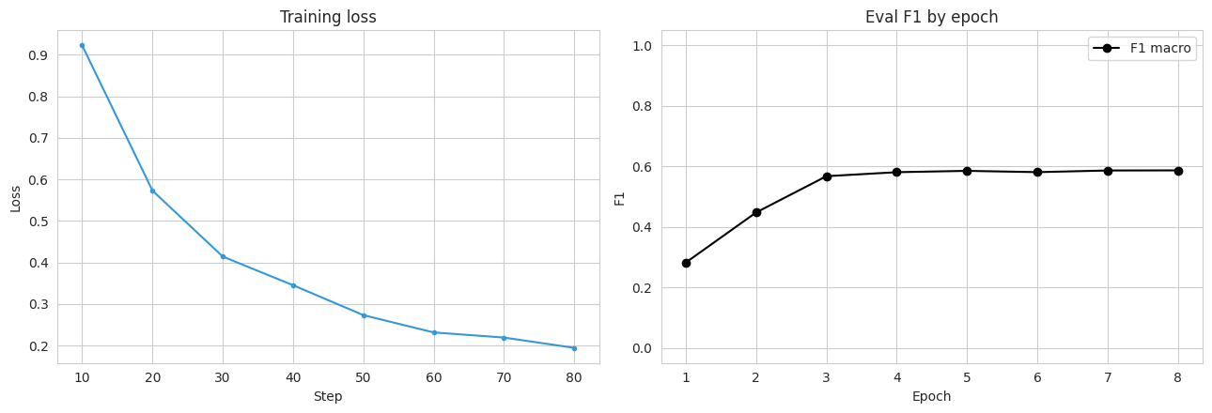
Figure 3: Training Loss and Macro F1 Across Epochs for the Code-Switching Model
Evaluation. On the held-out test set, the model reached 90.75% word-level accuracy. Table 2 breaks this down by label: performance on Urdu and English words was strong, but the model never predicted the MIX label at all.
Table 2: Precision, Recall, and F1-Score by Label for the Code-Switching Model
Label | Precision | Recall | F1-score
URD | 0.933 | 0.942 | 0.937
ENG | 0.836 | 0.812 | 0.824
MIX | 0.000 | 0.000 | 0.000

Figure 4 shows the same result as a confusion matrix: almost all of the model's mistakes involved confusing Urdu and English words with each other (for example, borrowed or ambiguous words), while the MIX row and column are empty.
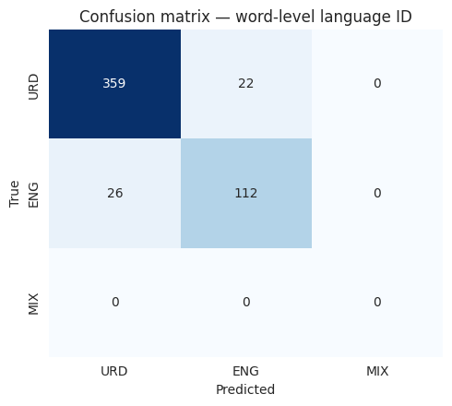
Figure 4: Confusion Matrix for Word-Level Language Identification
Debugging. The fact that MIX never appears was not really a training failure so much as a data problem, and tracing it back was one of the more useful debugging exercises of the internship. My word-level auto-labelling step only accepted tokens matching a strictly alphabetic pattern, which meant that hyphenated hybrid words, the most natural way hybrid Roman Urdu-English words show up in real text, were filtered out of the dataset before they ever had a chance to be labelled MIX. In other words, the model correctly learned that MIX essentially never occurs, because in its training data it never did. I see this as a genuine limitation of the current dataset construction, and I have reported it honestly here rather than leaving it out, since an evaluation section that only reports the flattering numbers would misrepresent what the model can actually do.
Application and deployment. After training, I published the fine-tuned model and the dataset to the Hugging Face Hub, and built a small Streamlit application that loads the model directly from the Hub and lets a user type in a sentence and see each word tagged and colour-coded by predicted language in real time. The project's documentation went through its own revisions alongside the code: the first README, drafted on 7 August with help from GitHub Copilot, was little more than a placeholder, and I did not develop it further until the notebook, the dataset, and the trained model were actually finished on 13 August. Once the model and app were working, I rewrote the README properly: fixing a Colab badge link that initially pointed at the wrong notebook path, replacing a placeholder Hugging Face dataset link with the real one, and reorganising the whole document around the finished product (live demo, results, how to run it) rather than around the research process that had produced it. I also went back through the repository afterward and removed an old assets folder and some superseded notebook versions left over from earlier drafts, since a repository that is easy for someone else to navigate felt like part of finishing the project properly, not an optional extra.
Figure 12 shows the deployed application correctly tagging a live example sentence, and Figure 13 shows the corresponding model page on the Hugging Face Hub.
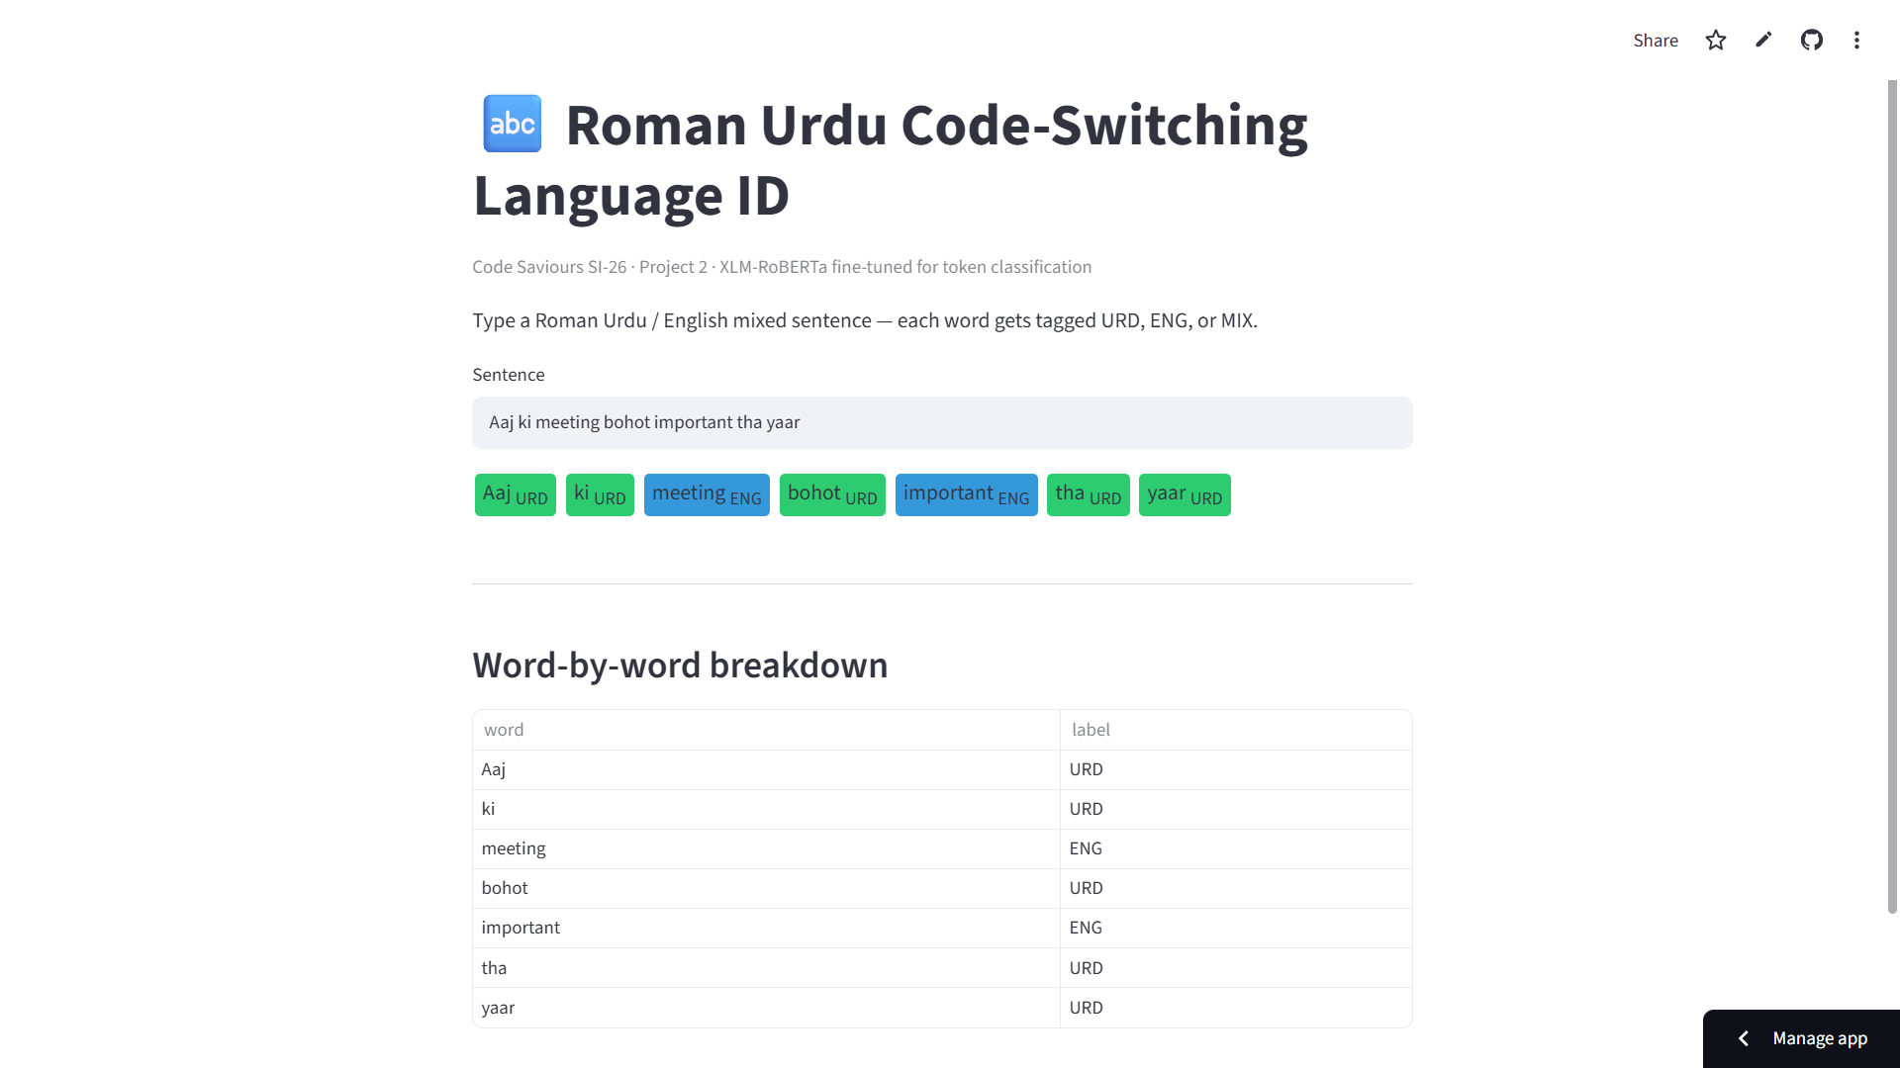
Figure 12: Screenshot of the Deployed Code-Switching Streamlit Application
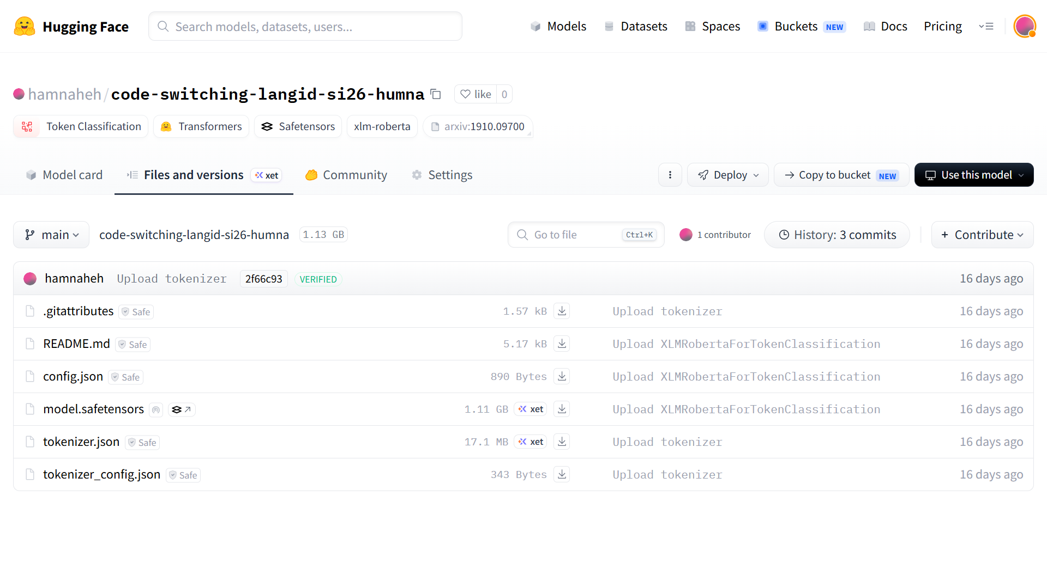
Figure 13: The Code-Switching Model's Page on the Hugging Face Hub
Project 2: Urdu Optical Character Recognition (OCR)
The second project, undertaken across Weeks 1 to 5 of the internship, was substantially larger in scope: building a custom OCR system for Urdu text. Urdu is normally written in the Nastaliq script, which is highly cursive, flows diagonally rather than sitting on a straight horizontal baseline, and changes each letter's shape depending on its position within a word. Combined with the fact that far less labelled Urdu OCR data exists publicly compared to English, this makes Urdu OCR a genuinely harder problem than English OCR, and it is also a good illustration of why off-the-shelf tools do not always transfer well across languages and scripts.
Data collection. Week 1 was mostly about building a labels.csv schema (image, text, category) that every later week would build on, and then actually filling it. I integrated UTRSet-Real, an academic dataset of genuine scanned Urdu text lines, using 60 of its lines as real-world ground truth, and rendered an initial batch of 20 synthetic Urdu line images by hand to give the dataset something to start with before I had a proper rendering pipeline. For the other real-world categories, I scanned book pages from the Urdu novel Jannat Ke Pattay, and took newspaper images initially from Akhbar-e-Jahan, Jang, and Dawn News. After noticing that these newspaper images were inconsistent in aspect ratio and quality compared to the rest of the dataset, I replaced that set with pages from Hamdard Naunehal instead. Typing out the Urdu transcription for every image by hand turned out to be far slower than I expected, since several of the book and newspaper captions ran to full paragraphs, so I uploaded the images to Google's Gemini one at a time, used it to transcribe the text, checked each result against the image myself, and pasted the confirmed transcription into labels.csv. I also hit a more mundane problem here: some transcriptions contained commas and quotation marks that broke the CSV format, which I had to go back and fix by hand.
Image preprocessing. My first preprocessing pipeline used a fixed brightness threshold and forced every image into the same fixed size, and it did not work well: on real photographed pages with uneven lighting, the fixed threshold turned shadowed regions into speckled noise, and forcing a uniform size distorted the aspect ratio of images that were naturally very different shapes (single cropped text lines versus full book or newspaper pages). I rebuilt the pipeline to resize each image while preserving its aspect ratio, denoise it gently, and then binarise it using Otsu's method, which recalculates the ideal brightness cutoff for each image individually instead of assuming every photo has the same lighting. Figure 5 compares raw and processed images side by side, and Figure 6 shows why Otsu matters in practice: for one processed page, Otsu automatically chose a threshold of 177, far from the old fixed cutoff of 127, a difference that would have badly misclassified that image's pixels under the original approach.
Two smaller issues showed up once this pipeline was running. First, my notebook's working directory was not always the folder I expected, so raw images were not loading from the right place; I added a small diagnostic cell that searches the workspace for folders named "raw" and reports how many images it finds, then pointed RAW_DIR at the correct path, which sounds trivial but saved a lot of confused debugging. Second, Otsu is not foolproof: on a few images with a lot of white padding or border around the actual text, it picked a threshold that turned almost the entire image black. I caught this by adding an automated check that measures the percentage of black pixels in every processed image and flags anything at the extremes, rather than by scrolling through all 153 images by eye. Separately, I also had to clean up the repository itself partway through, since a batch of processed PNG files had been committed without filtering and had made it noticeably larger than it needed to be; I removed the unnecessary binaries, kept only the files needed to reproduce the pipeline, and added basic error handling so that invalid or corrupted images get moved aside instead of silently breaking a later cell.
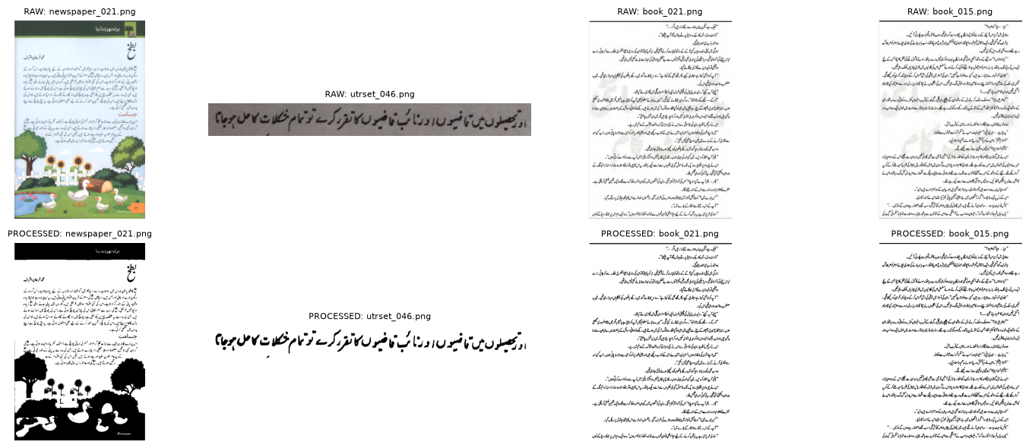
Figure 5: Sample Images Before and After the Preprocessing Pipeline
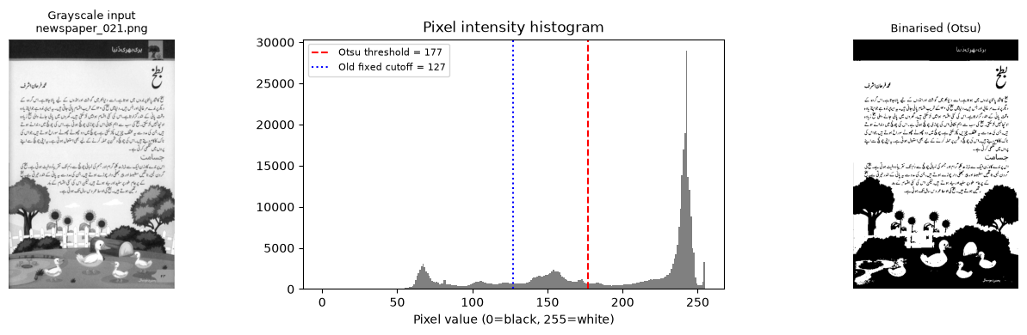
Figure 6: Otsu's Adaptive Threshold Compared with the Original Fixed Cutoff
Baseline evaluation with Tesseract. Before building a custom model, I tested Tesseract, a widely used open-source OCR engine, on five of my processed images using its Urdu language pack, to understand how much a custom model was actually needed. The results were poor: on the two images where I had exact ground truth to compare against, Tesseract recovered only 27% and 0% of the real words respectively (Figure 7). Looking across all five images, one short, clean line survived mostly intact, one produced only a single recoverable fragment, and the two full-page images were the worst: Tesseract regularly output characters and digits that were not anywhere in the source image, which is a different and more concerning kind of failure than simply missing a few words. This baseline gave me clear, evidence-based justification for why the project needed a custom-trained model rather than an existing OCR tool.
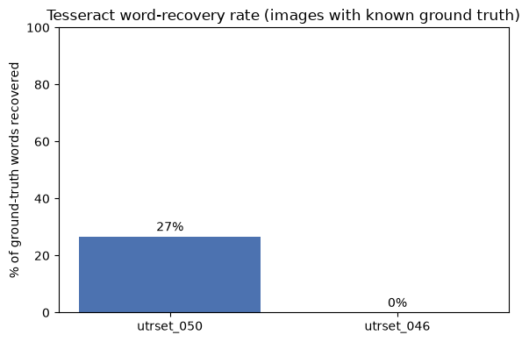
Figure 7: Word-Recovery Rate of Baseline Tesseract OCR on Urdu Text
Dataset expansion. To increase the amount of training data available, I investigated UTRNet's UTRSet-Real and UTRSet-Synth datasets (academic datasets of real and synthetic Urdu text lines, released for research use), and built a proper rendering engine using the Nastaliq and Naskh fonts over a public corpus of roughly 137,000 Urdu headlines, with right-to-left aware text shaping so that letters joined correctly instead of sitting apart. This produced 110 additional synthetic Urdu text-line images and brought the working dataset to 263 labelled image-text pairs. Wiring this into a proper PyTorch Dataset class was its own small project: some images failed to load because a handful of files were corrupted, which I handled with try-except blocks; the tokenizer needed padding set explicitly to max_length or batches came out with mismatched shapes; and the pixel tensors needed an extra squeeze() to come out in the [3, 384, 384] shape the model expected. I also had to pin the transformers library to version 4.57.6, since the newer 5.x release had a backwards-compatibility issue with TrOCRProcessor that broke this notebook.
Model development and training. I fine-tuned microsoft/trocr-base-printed, a transformer-based encoder-decoder OCR model with roughly 334 million parameters, on the 263-image dataset (211 for training, 52 for testing, an 80/20 split). Figure 8 shows this split along with the spread of ground-truth caption lengths, which ranged from short headlines to full transcribed pages of several thousand characters. Training ran for 3 epochs with a batch size of 4 and a learning rate of 5e-5; Figure 9 shows that training loss dropped substantially over the first few batches and then levelled off at around 3.5.
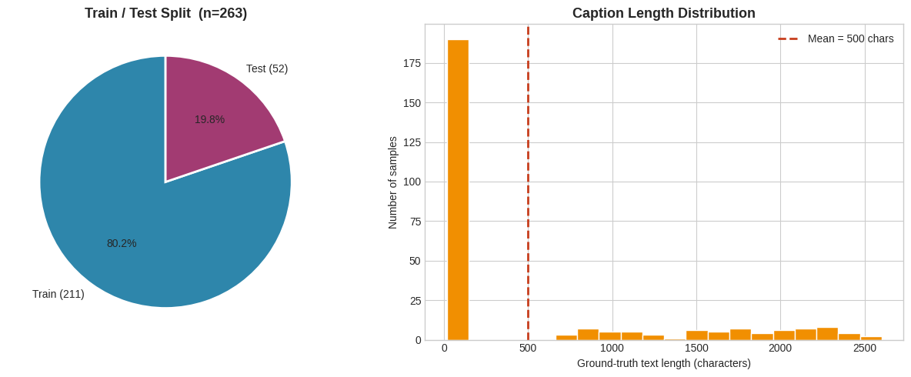
Figure 8: Train/Test Split and Ground-Truth Caption Length Distribution
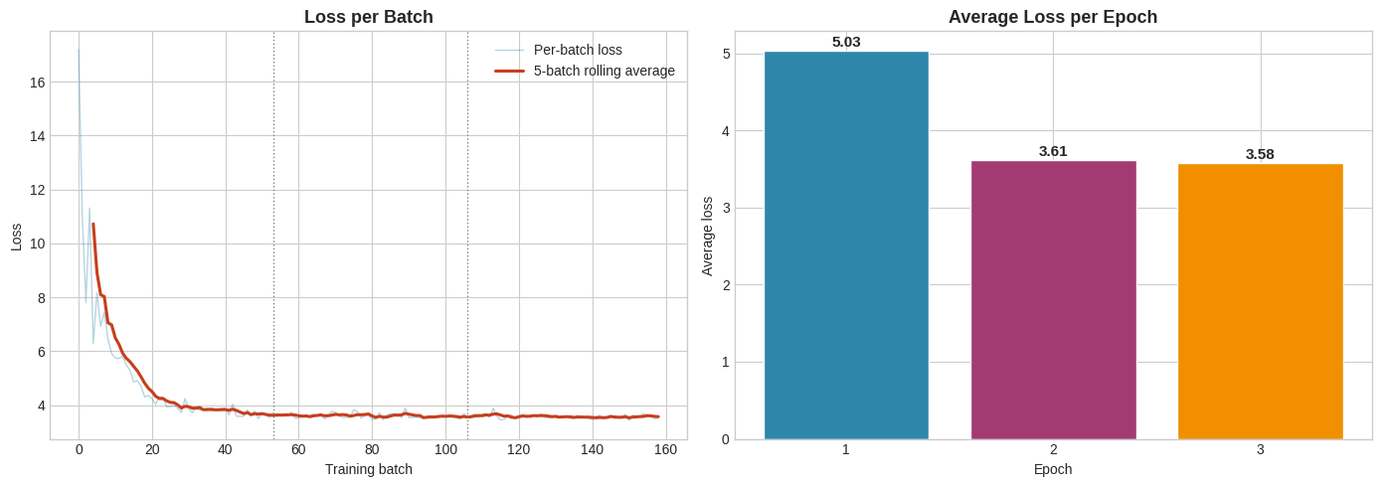
Figure 9: TrOCR Fine-Tuning Loss Across Training
The Week 4 data bug. Before I could judge the model at all, I ran into the single most instructive bug of this project. Comparing the number of rows in labels.csv against the number of image files that actually loaded, I found that 153 of 263 rows, 58 percent of the dataset, were being silently skipped during training. There was no error and no warning; the training loop simply ran on whatever happened to load. Tracing the path-joining logic by hand, I found that labels.csv had accumulated two different, incompatible path conventions from different weeks of data collection, and my loader only handled one of them. I wrote a resolve_image_path() function that tries the direct path first and falls back to the older convention if that fails, which brought the dataset back to its full 263 rows. Finding this had less to do with any single line of code and more to do with a habit: I only caught it because I had started comparing row counts against file counts as a matter of course, rather than assuming that a notebook running without errors meant it was running correctly.
Evaluation. On the 52 held-out test images, the fine-tuned model reached 0% exact-match accuracy and a mean character-level similarity of only about 0.1%: every single prediction collapsed to the exact same fixed string of placeholder characters, regardless of what the input image actually contained (Figure 10). Figure 11 shows this directly against sample test images and their ground truth. The output length stayed constant at 20 characters no matter whether the true caption was 22 characters or 110, which is the signature of a model that has collapsed rather than one that is partially working. Working backward from this, I traced the most likely causes to three things: trocr-base-printed's decoder is a RoBERTa model pretrained almost entirely on English text, so it starts with very little representation of Urdu script; a domain gap between the mix of scanned, photographed, and synthetic images in my dataset and whatever printed text the base model originally saw; and 211 training examples across only 3 epochs, which is a small amount of signal to teach a model an entirely new writing system from close to zero. Further documentation on the project also points to a repeated-character degeneration pattern consistent with exposure bias, a known failure mode in sequence generation models, and describes later training runs with more epochs and generation-time adjustments, such as a repetition penalty, that reportedly brought the validation character error rate down toward 1.365; at the time of writing that follow-up work is a documented next step rather than a result I can re-verify in this notebook, so I have reported the confirmed figures above rather than a number I could not check myself.
Beyond the dataset bug, a handful of environment issues shaped how I worked during this stretch of the project. The corpus file that fed the synthetic renderer was sometimes not found at all, because my notebook used a path that did not resolve the same way on every machine; I added an existence check with a fallback and a clear error message instead of letting it fail somewhere else with a confusing traceback. Rendering Urdu text with right-to-left shaping depended on a system library called libraqm that is not always installed in a fresh Colab runtime, so I added a check, PIL.features.check("raqm"), that uses proper RTL shaping when the library is available and falls back to plain text layout when it is not, rather than crashing outright. Because Colab recycles its runtime and clears local files every few hours, I mounted Google Drive and pointed the repository clone and font files at a persistent Drive folder so that checkpoints and downloaded assets survived between sessions instead of disappearing. I also found that package installs were sometimes going to a different Python interpreter than the one the notebook was actually running on; switching to an explicit sys.executable -m pip install pattern fixed the import errors that had been coming from that mismatch. None of these were glamorous fixes, but each one had already cost me a confused session of debugging before I understood what was actually happening.
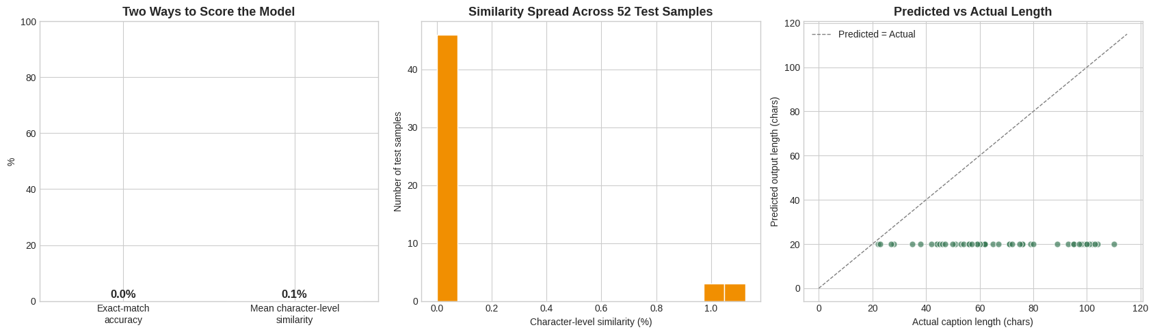
Figure 10: Evaluation of the Fine-Tuned OCR Model on the Held-Out Test Set
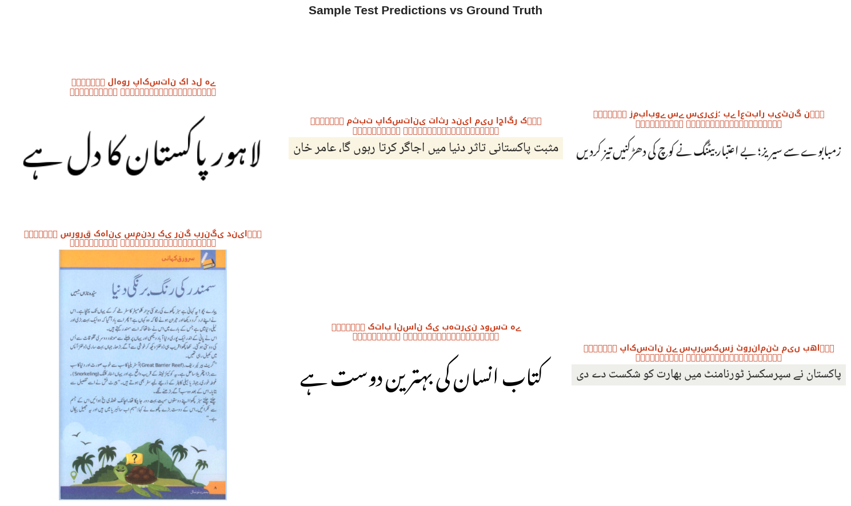
Figure 11: Sample Test Predictions Compared with Ground Truth
Application and deployment. Despite the model's limitations, I still built and deployed a complete application around it: a Streamlit app that accepts an uploaded Urdu image, preprocesses it, runs it through the fine-tuned model pulled live from the Hugging Face Hub, and displays the recognised text. Getting there took its own round of fixes: the app's MODEL_ID was left as a placeholder for most of Week 5 while training was still running, and the README's results table simply said "fill in". Once the final model was actually pushed to the Hub under hamnaheh/trocr-urdu-si26-week4, updating that one line felt like a small change, but it was the real milestone: it meant training had finished and a working model genuinely existed for the app to load, not just a plan for one. Deploying an imperfect model honestly, rather than only deploying projects that work perfectly, felt like a realistic and valuable part of the experience, since production Machine Learning systems rarely start out working well.
Figure 14 shows the application's upload screen, and Figure 15 shows the model's actual output on a real uploaded test image, reproducing the same repeated-character collapse described above outside of the notebook environment. Figure 16 shows the project's GitHub repository, consistent with the commit history described earlier in this section.
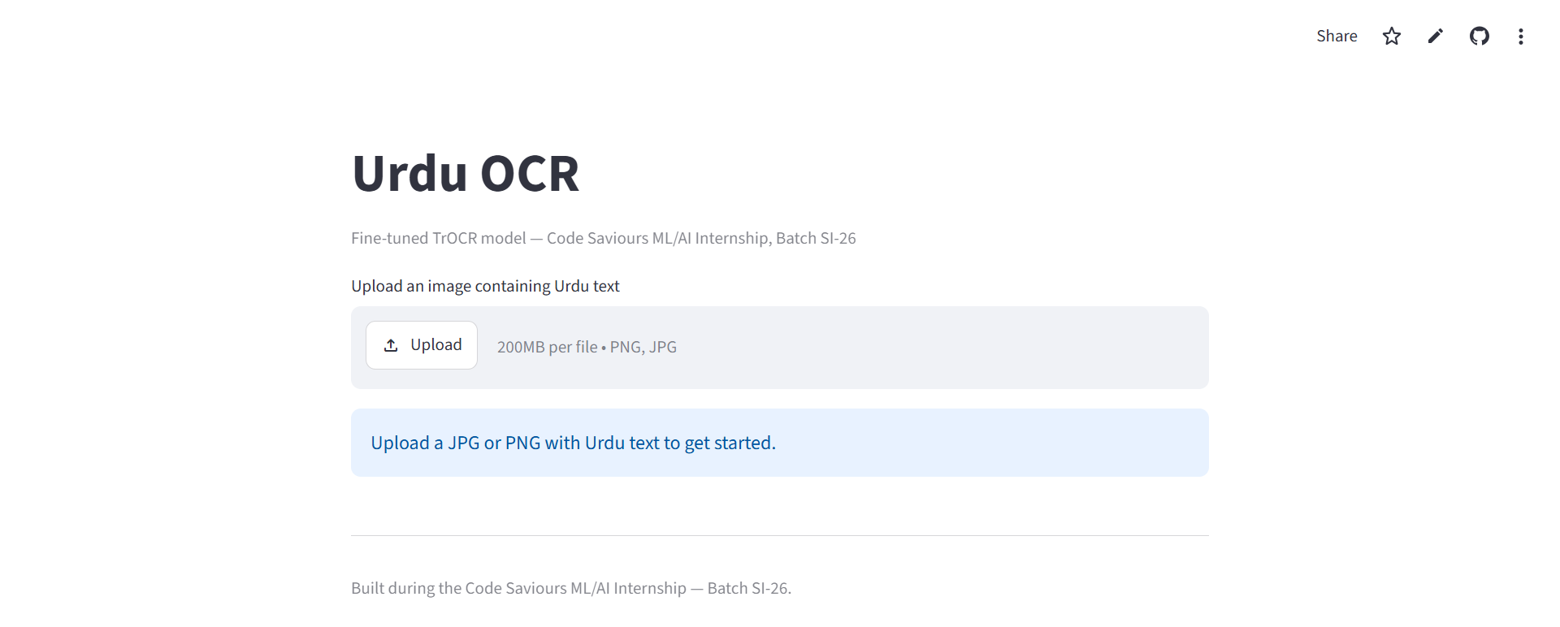
Figure 14: Screenshot of the Deployed Urdu OCR Streamlit Application
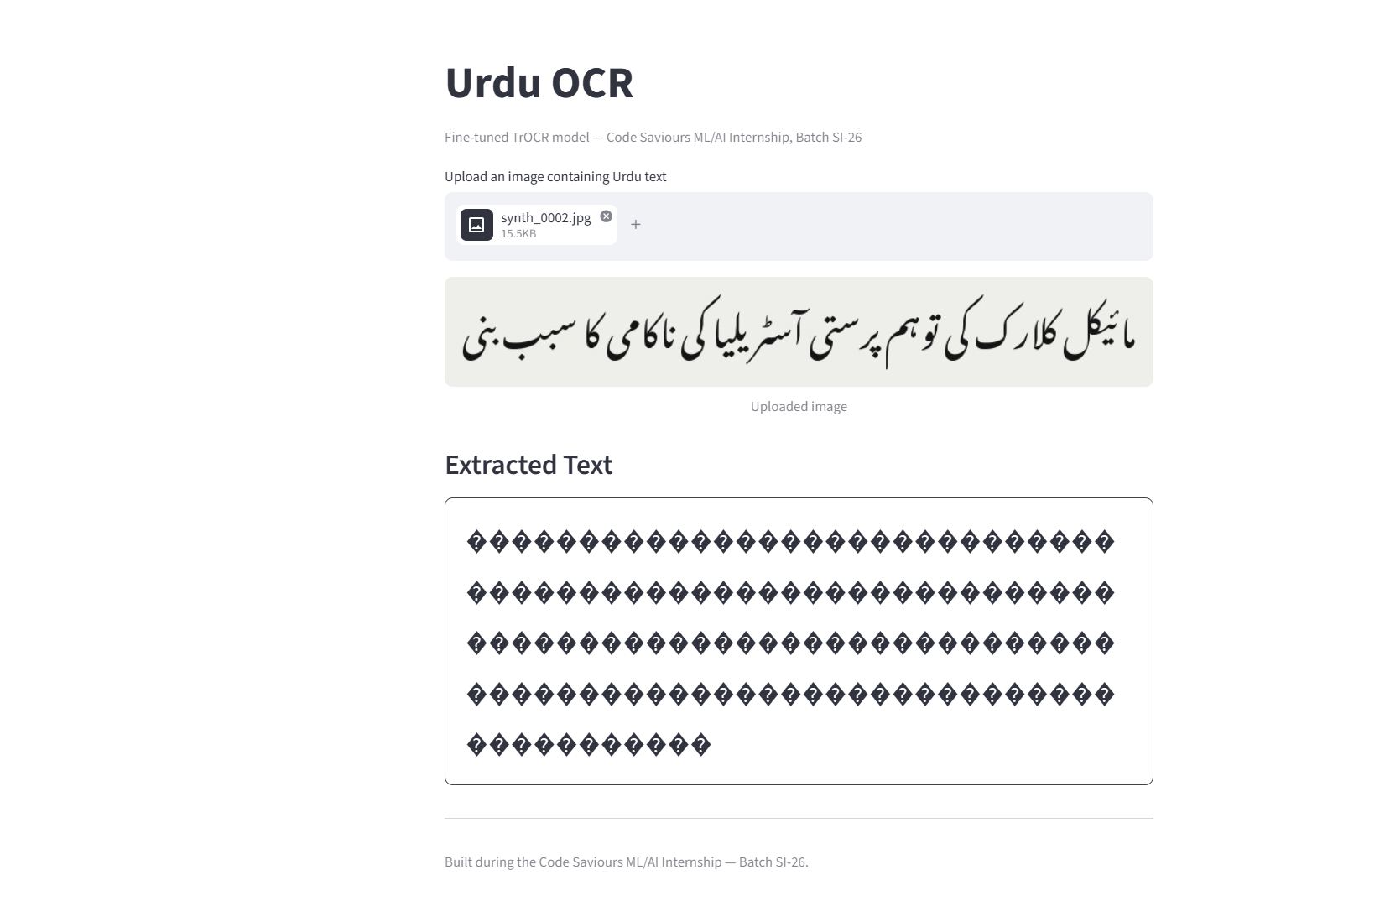
Figure 15: The Deployed Model Producing the Same Repeated-Character Output on a Live Test Image
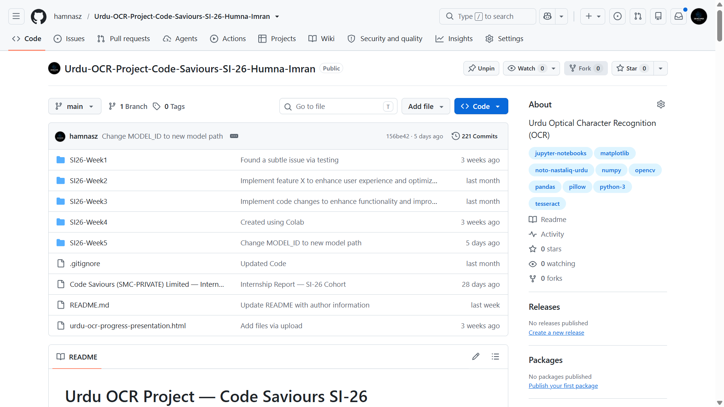
Figure 16: The Urdu OCR GitHub Repository Showing the Weekly Folder Structure and Commit History
Table 3: Comparison of the Two Internship Projects
Aspect | Project 1: Code-Switching ID | Project 2: Urdu OCR
Task type | Word-level token classification (NLP) | Image-to-text generation (vision + NLP)
Base model | xlm-roberta-base | microsoft/trocr-base-printed
Dataset size | 220 sentences / 2,490 word labels | 263 image-text pairs
Final result | 90.75% word-level accuracy | 0% exact-match (failure diagnosed and documented)
Deployment | Streamlit app + Hugging Face Hub | Streamlit app + Hugging Face Hub

- Learning Outcomes
Working on these two projects gave me practical experience with almost the entire Machine Learning workflow, in a way that lecture-based coursework in my BS Artificial Intelligence degree had only partially prepared me for. Reading about data cleaning, tokenisation, or train/test splitting in a course is different from actually writing the code that filters 15,000 sentences down to a genuinely useful 220, or from discovering that a filtering rule I had written myself had quietly removed an entire label from my own dataset.
On the Natural Language Processing side, I learned how to approach code-switching as a concrete labelling problem, how to fine-tune a multilingual transformer model (xlm-roberta-base) for token classification using the Hugging Face Trainer API, and how to read training curves and confusion matrices critically rather than simply checking whether the overall accuracy number looked acceptable.
On the computer vision and OCR side, I learned why classical image preprocessing choices, such as thresholding method and resize strategy, are not minor implementation details, since they can make the difference between usable and unusable input data. I also gained a much more realistic understanding of what fine-tuning a pretrained model on a script it has barely seen actually requires: it is not simply a matter of running a training loop for a few epochs, and small dataset sizes matter a great deal when a model needs to learn new visual and linguistic patterns essentially from scratch.
Beyond the two specific projects, I also became noticeably more comfortable with the tooling that surrounds real Machine Learning work: structuring a project across GitHub Codespaces and Google Colab, using Git and GitHub properly for version control across many weekly notebooks, publishing models and datasets to the Hugging Face Hub, and turning a notebook-based result into an actual deployed Streamlit application that someone other than me could open and use. These are skills that are easy to underweight in an academic setting, but they were a large part of what made this feel like a real project rather than a classroom exercise.
- Professional Growth and Reflections
The internship pushed me to work far more independently than most of my university coursework does. There was no single instructor checking each step in real time, so when something did not work, such as the OCR model collapsing to a single repeated output, the responsibility for diagnosing it and deciding what to do next was mine. I found this genuinely difficult at times, particularly when I could not immediately tell whether a poor result was a bug in my code, a limitation of the dataset, or a limitation of the underlying model, and I had to develop a habit of checking each of those possibilities systematically rather than guessing.
I also became better at managing a project across multiple weeks rather than in a single sitting. Both projects were structured as a sequence of weekly milestones, and staying organised across notebooks, data folders, and changing file paths (something that directly caused one of the bugs I had to fix in the OCR project) taught me the practical value of consistent naming conventions and clear documentation, not as an abstract best practice but as something I felt the cost of firsthand when I got it wrong.
Perhaps the most important shift for me was in how I think about a disappointing result, and a comment from my industry supervisor pushed that shift along more than anything else: she told me a 0% accuracy result is perfectly fine, as long as I can actually explain why it happened. Before that comment, I think I would have been tempted to under-report or gloss over a result like the OCR model's 0% exact-match accuracy. Working through it instead, tracing it back to a plausible cause, and writing it up honestly, felt like a more professional and ultimately more useful response than presenting only the parts of the work that succeeded. I do not think this internship turned me into an expert in either Natural Language Processing or Optical Character Recognition, but it did give me a much more realistic sense of what applied AI work actually involves, including the parts that do not go as planned.
I also learned, somewhat separately, that training a model and shipping something another person can actually click on and use are genuinely different skills. Getting the code-switching project from a working notebook to a live link that anyone could open took a different kind of effort than getting the model to 90% accuracy in the first place, and I do not think I appreciated that distinction before this internship. Between the two projects, I went from auditing a folder of 100-odd images in Week 1 to defending a 0% result with a root-cause explanation in Week 4, and from a fine-tuned model sitting in a notebook to two links anyone can actually click; that range is probably the best summary I can give of what changed for me over these eight weeks.
- Recommendations
The weekly milestone structure used for both projects worked well for keeping the work paced and manageable, and I would recommend keeping it for future interns. It might help future cohorts, though, to have a short mid-internship checkpoint focused specifically on data pipeline correctness (checking things like label distributions and file path consistency early), since several of the more time-consuming bugs I encountered, in both the code-switching label filter and the OCR file paths, would likely have been caught earlier with a dedicated review step rather than being discovered later during model evaluation.
For the OCR project specifically, given how much harder the problem turned out to be than a three-epoch fine-tuning run could address, it may be worth signalling to future interns earlier that a first attempt at fine-tuning a model on a low-resource script is likely to fail outright, so that time and expectations can be planned around a longer, more iterative training process from the start rather than treating an initial failed run as unexpected.
More generally, I would recommend that future projects in this programme build in a small amount of dedicated time for baseline comparisons, such as the Tesseract baseline I ran before building the custom OCR model, since that step was one of the most useful things I did: it gave me clear, defensible evidence for why the custom model was worth building at all, rather than relying on assumption alone.
- Conclusion
This internship gave me the opportunity to take two Artificial Intelligence projects, one in Natural Language Processing and one in Optical Character Recognition, from an initial idea through data collection, preprocessing, model training, honest evaluation, and finally deployment. The Roman Urdu-English code-switching model reached a solid 90.75% word-level accuracy and is deployed as a working Streamlit application, while the Urdu OCR project, despite a fine-tuned model that did not yet produce usable output, taught me just as much through the process of diagnosing why it failed and documenting that honestly.
Across both projects, I applied and deepened concepts from my BS Artificial Intelligence coursework, including transformer-based model fine-tuning, evaluation methodology, and classical image preprocessing, while also building practical skills in version control, cloud-based model hosting, and application deployment that a purely academic setting does not always provide. Just as importantly, I developed a more realistic, professional attitude toward Machine Learning work, one where an unflattering result is treated as information to investigate rather than something to hide. I expect both the technical skills and this attitude toward honest evaluation to be directly useful in my continued studies and in any future AI-related work I take on.
Appendices
Appendix A: Internship Offer Letter
[A scanned copy of the internship offer letter issued by Code Saviours is to be inserted here.] (Mandatory)
Appendix B: Internship Completion Certificate
[A scanned copy of the internship completion certificate is to be inserted here.] (Mandatory)
Appendix C: Supporting Documents
[Any additional supporting documents, such as task sheets or correspondence, may be inserted here.] (Optional)
[Photographs from the internship, if available, may also be included in this appendix.] (Optional)

